CNA (Practical-2)

PR 2:Create and configure Compute Engine VM instance

STEPS:
- Open website - https://www.skills.google
- Click on Sign - Select Sign in with Google
- From left panel - Select "Catalog"
- Type "cloud virtual machine" - in "What you want to learn today" search box
- Select "virtual machine" from search
- Select "Create virtual machine"
- Select "Start Lab"
- Select "Launch with 1 Credit"
- Right click on “Open Google Cloud Console” button and select “Open link in new Tab”
- You can find Username, Password, and Project ID
- Copy "username" and "password" from "skills.google" website
- Use them to "Sign in"
- Select "I Understand" button
- Select check box "Terms of Service" - "Click on Agree and continue"
- Click on "Select a Project" - One Dialog box will open
- Select project ID such as "qwicklabs-gcp-....." if not selected.
- Select “Compute Engine” from left panel.
- Select “Create Instance” from top.
- In Machine Configuration.
  - Name: linux-vm-1

  - Region: choose any (e.g., us-central1) or do not change.
  - Zone: do not change.
- From options: select General Purpose

Series: E2
  - Machine type: e2-medium (Good default, low cost)
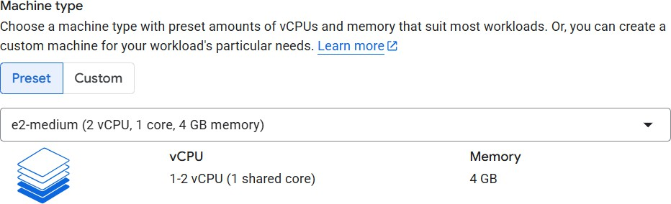

- From left panel select “OS and Storage”
- Click on “Change” button
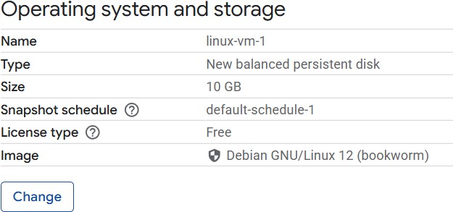
- Select bellow options:
  - Operating system: Ubuntu
  - Version: Ubuntu 22.04 LTS
  - Boot disk type: Balanced persistent disk
  - Size: 10 GB
- From left panel select “Networking”

- Select check box of: (If you want to run web server) Allow HTTP traffic
Allow HTTPS traffic
- Click on “Create” to create VM
- Click on SSH to run Linux server in browser
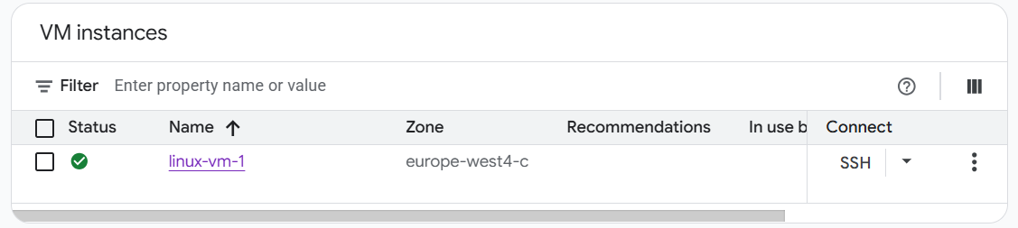
- Using SSH browser you can
  - Update the OS
  - Install / remove packages
  - Manage users and permissions
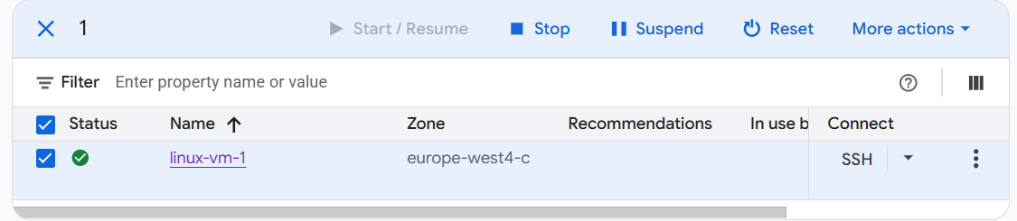
- Select the check box against the VM name

- Now, you can Start, Stop, Suspend (OS is not Shut down), reset (restart).
- From More actions: Select “Delete”
- Click on “Delete” button.

